**Backend Development Repository Structure:**

* The Back end is mainly a Flask Rest API
* The api_module will handle all the call from the client side
* The file structure is represented as follows :

│   ├── api_module

│   │   ├── __init__.py

│   │   ├── chat_controller.py

│   │   ├── company_controller.py

│   │   ├── employee_controller.py

│   │   ├── helpers.py

│   │   ├── issue_controller.py

│   │   ├── models.py

│   │   ├── project_controller.py

│   │   ├── role_controller.py

│   │   ├── sprint_controller.py

│   │   ├── task_controller.py

│   │   ├── team_controller.py

│   │   └── user_controllers.py

│   └── templates

│   ├── 404.html

│   └── docstring.html

├── config.py

├── local

│   └── db

│   └── app.db

├── readme.md

├── run.py

├── static

└── tests

├── payload.txt

└── pmp_backend.postman_collection.json

* Run a development server using the run.py
  + GET : <http://0.0.0.0:5005/api/>
* app.db : SQLite Database created by models.py

**Database Model: E-R Diagram:**

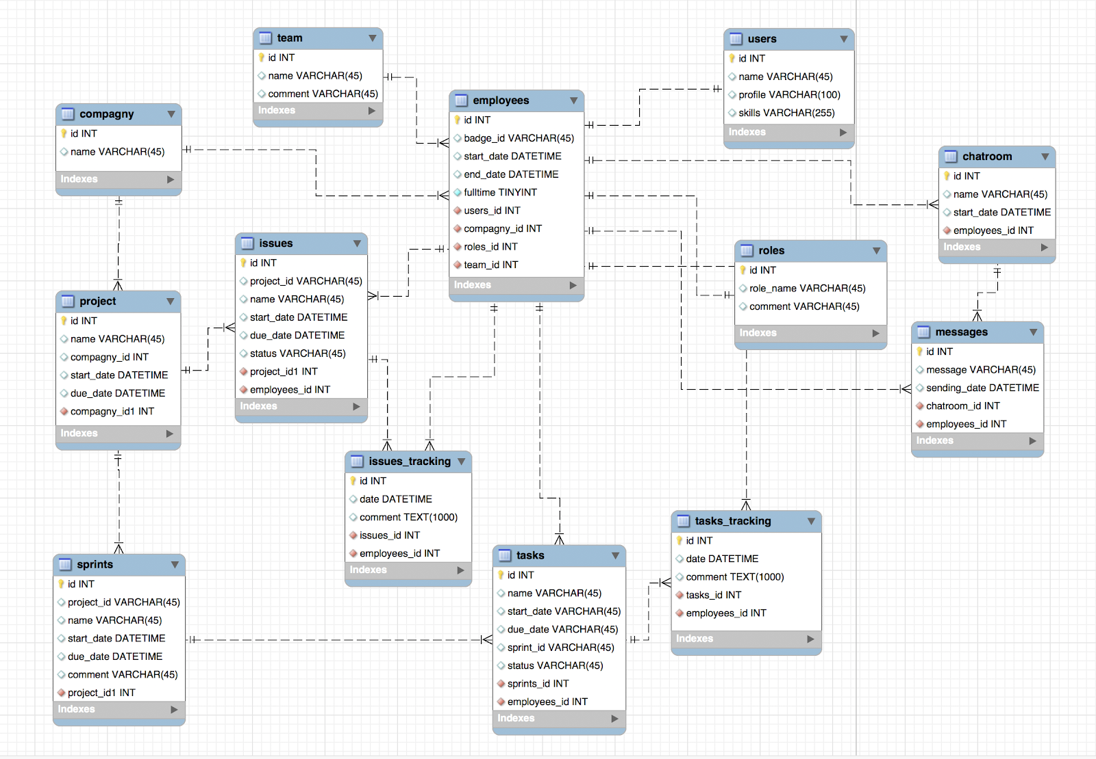

**Backend controller job description:**

* Company_controller.py: Controller Job to create a new company, fetch specific company and fetch list of companies.
* Employee_Controller.py: Create employee controller job to create new employee under a company, fetch all employees under a company, and fetch all employees under a team.
* Issue_Controller.py: Create issue controller job to:

- create new issues under project, with employee name, start date and due date

- Update the issue for due date and status

- Get all the issues assigned to a user

- Get all the issues under a project

- Get all the issues for a project filter by status

- Create comments under issue tracking

- Delete comments from issue tracking

* Project_Controller.py: Create project controller job to create new projects, fetch a project, fetch all projects within a company, and throw warning if searched project is not found.
* Role_Controller.py: Create role.py job to create role for a user id, get all the roles for a user id, get specific role for a user id
* Sprint_Controller.py: Create sprint_controller.py job to create a sprint, get all the sprints under a project, get all the sprints under a user, get specific sprint under project.
* Task_Controller.py: Create tasks controller job to:

- create new tasks under sprint, with employee name, start date and due date

- Update the tasks for due date and status

- Get all the tasks for a user

- Get all the tasks for under a sprint

- Get all the tasks for a sprint filter by status

- Create comments under task tracking

- Delete comments from task tracking

* Team_Controller.py: Create team controller job to create new teams under a company, fetch all teams for a user and fetch one team under a user id
* User_Controllers.py: Create user_controllers.py python file to create new users ids, get and delete existing user ids.